Article
Machine Learning and Kalman Filtering for Precise Satellite Orbit Determination: Implications for Precise Point Positioning
Furkan Karlitepe ¹*, Emirhan Uysal ²
Academic Editor: Firstname Lastname
Received: date
Revised: date
Accepted: date
Published: date
Copyright: © 2026 by the authors. Submitted for possible open access publication under the terms and conditions of the Creative Commons Attribution (CC BY) license.
¹ Affiliation 1; furkan.karlitepe@gop.edu.tr
² Affiliation 2; emirhan.uysal2826@gop.edu.tr
* Correspondence: furkan.karlitepe@gop.edu.tr
Abstract
This study evaluates the impact of satellite orbit reconstruction methods on Precise Point Positioning (PPP) performance using high-rate orbit products. One-second satellite positions were generated from sparse precise orbit datasets (300 s and 900 s intervals) using 9th-degree Lagrange interpolation, Extended Kalman Filter (EKF), and machine learning models (RF, SVR, KNN, MLP). The methods were assessed through LOO-CV and integrated into RTKLIB PPP processing. Results show that EKF and Lagrange provide the highest accuracy, while machine learning models yield significantly larger errors. ENU-based PPP results confirm that orbit quality strongly affects positioning performance, with high-quality products (CODE, JAXA) producing consistent results and lower-resolution products (GRG, SHA) causing significant degradation, particularly in the vertical component.
Keywords: GNSS; PPP; EKF; Machine Learning

1. Introduction
Precise Point Positioning (PPP) has emerged as a fundamental technique for achieving centimeter level accuracy using a single Global Navigation Satellite System (GNSS) receiver by leveraging precise satellite orbit and clock products [1,2]. Unlike differential approaches that eliminate errors through differencing with respect to a reference station, PPP relies on correction information to achieve positioning accuracy [3]. Broadcast ephemerides have been considered unsuitable for PPP due to their limited accuracy, though the emergence of new constellations such as Galileo and BeiDou-3 has prompted a reassessment of this constraint [1, 4, 5]. Recent advancements in State Space Representation (SSR) corrections and augmentation services have demonstrated that high accuracy positioning is achievable through the broadcasting of precise orbit and clock products via GNSS constellations [6]. The International GNSS Service (IGS) has played a key role by providing high quality GNSS products since 1994, which include definitive satellite ephemerides and clock information necessary for correcting orbit and clock errors to reduce positioning error to the centimeter level [7]. The IGS provides various levels of precise ephemerides and satellite clock corrections, with final products offering orbit accuracy of approximately 2.5 cm and clock precision around 75 ps, while ultra-rapid products deliver degraded performance with near real-time latency [8]. To obtain this level of accuracy, PPP requires correction for error sources, including satellite orbit and clock biases, satellite antenna phase center variations, receiver clock error, atmospheric delays, phase biases, solid-earth tides, and ocean loading. Additional corrections such as relativistic effects, phase wind-up, and pole-tide must also be applied to ensure the integrity of the positioning solution [9,10]. Despite the availability of these precise products, PPP remains constrained by the latency of final orbit and clock corrections, which has driven the development of real-time augmentation services and prediction models to support high precision applications [11,12]. Real-time PPP implementations necessitate the continuous availability of precise orbit and clock corrections, a requirement that has driven the development of augmentation services capable of delivering these products with minimal latency [13]. In this context, the IGS initiated a pilot project for real time activities in 2001 to improve RT-PPP accuracy, aiming to provide Real-Time Service (RTS) products, primarily orbit and clock corrections, to mitigate satellite ephemeris and clock errors [14]. The geodetic research community has investigated alternative orbit estimation [15], including filter-based smoothing and machine learning regression techniques, to enhance satellite coordinate reconstruction at observation epochs and improve positioning accuracy beyond the capabilities of interpolation methods [16,17,18]. This study addresses this gap by comparing Lagrange interpolation, an Extended Kalman Filter (EKF) based smoothing approach, and machine learning models based on Random Forest (RF) regression, Support Vector Machines (SVM), K-Nearest Neighbor (KNN) and Multi Layer Perceptron (MLP) to evaluate their impact on PPP positioning accuracy. The evaluation is conducted using 1 Hz GNSS observations from a station with known coordinates, where satellite positions at observation epochs are derived from precise orbit products using ninth-degree Lagrange interpolation, an EKF based smoothing approach, and machine learning regression [14,19]. Machine learning algorithms have also been introduced to address PPP challenges where SVM have demonstrated superior performance compared to RF models in enabling PPP-AR [20]. Beyond ambiguity resolution, machine learning approaches have been investigated for predicting satellite orbit and clock corrections to mitigate the latency in final products, with studies indicating that machine learning models can achieve centimeter level accuracy when modeling differences between ultra rapid and final orbit products. Recent advancements in EKF based orbit determination have further demonstrated that real time estimation can outperform standard ultra rapid products in terms of convergence time and accuracy for kinematic PPP-AR applications [21]. While EKF based approaches have shown promise, recent studies indicate that purely machine learning can further augment traditional modeling, particularly for systems like BeiDou-3 where classical techniques exhibit notable performance disparities compared to GPS and Galileo [22]. This observation underscores the necessity of modeling to ensure consistent multi GNSS performance, as the distinct constellations and signal characteristics of BeiDou-3 may not be fully captured by estimation [23]. Recent studies have demonstrated that machine learning algorithms can improve orbit prediction accuracy by more than 45% [24,25]. Similarly, SVM based solutions have been employed to reduce latency in PPP processing, achieving reductions of approximately 30% in the standard deviation and 20% in the range of clock corrections [23]. Consequently, the geodetic community has investigated interpolation algorithms such as Lagrange to reconstruct satellite positions at the observation epoch from the sparse 15-minute or 5-minute intervals provided in precise products [23]. While interpolation remains the standard approach due to its computational efficiency, studies have increasingly explored EKF based smoothing and machine learning regression techniques to better capture the behavior of satellite orbit between product epochs.

2. Materials and Methods

2.1. Lagrange Interpolation for High Rate Orbit Reconstruction
Lagrange interpolation is a polynomial interpolation technique used to estimate intermediate values from a discrete data set. In the context of GNSS precise orbit products (e.g., SP3 files), satellite position coordinates are typically provided at fixed intervals such as 300 second or 900 second. To obtain higher temporal resolution (e.g., 1 s), interpolation methods are commonly employed.
For a first-degree Lagrange polynomial, two data points $\left(x_{1},y_{1}\right)$ and $(x_{2},y_{2})$ are required. The interpolating function passing through these points can be expressed on Eq (1).
$f\left(x\right)=\frac{y_{1}}{x_{1}-x_{2}}\left(x-x_{1}\right)+\frac{y_{2}}{x_{2}-x_{1}}\left(x-x_{2}\right)$ (1)
This formulation ensures that the polynomial exactly matches the known values at x_1and x_2. For higher accuracy in satellite orbit interpolation, higher-degree polynomials are generally used. A second degree Lagrange polynomial requires three data points $\left(x_{1},y_{1}),(x_{2},y_{2}),(x_{3},y_{3}\right)$ and is written as Eq 2.
$f(x)=y_{1}\frac{\left(x-x_{2})(x-x_{3}\right)}{\left(x_{1}-x_{2})(x_{1}-x_{3}\right)}+y_{2}\frac{\left(x-x_{1})(x-x_{3}\right)}{\left(x_{2}-x_{1})(x_{2}-x_{3}\right)}+y_{3}\frac{\left(x-x_{1})(x-x_{2}\right)}{\left(x_{3}-x_{1})(x_{3}-x_{2}\right)}$ (2)
In general, an n-th degree Lagrange polynomial requires n+1 known data points. For GNSS precise orbit interpolation, high degree implementations (e.g., 8th or 9th degree) are frequently adopted in order to minimize interpolation error between precise orbit epochs. When applied to GNSS satellite coordinates, the interpolation is performed separately for each coordinate component (X, Y, Z) in the Earth-Centered Earth-Fixed (ECEF) frame. The polynomial order must be selected carefully for too low a degree may introduce interpolation bias, whereas excessively high degree polynomials may cause numerical instability

2.2. Estimation satellite orbit with Kalman Filter
Kalman filter–based estimation is widely used in GNSS positioning [26] and Precise Orbit Determination (POD) [27]. It recursively estimates time-varying states while quantifying uncertainty through a covariance matrix. The algorithm operates through prediction and correction steps, where the Kalman gain optimally balances model dynamics and measurement information. Due to its recursive formulation, it is well suited for sequential problems such as continuous satellite orbit reconstruction.
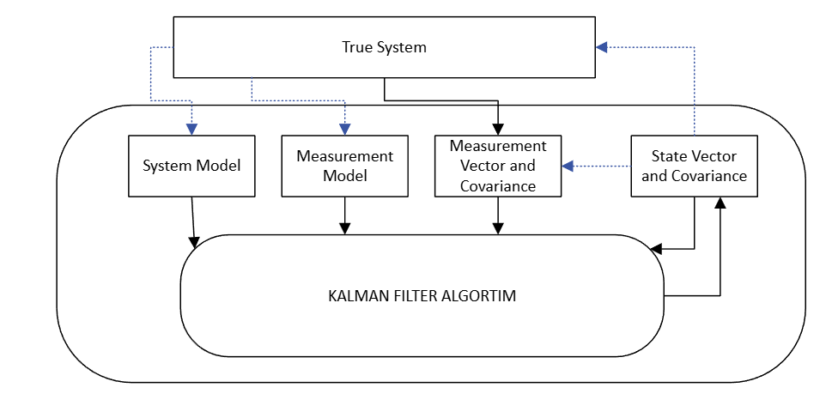
Figure 1. This is a figure. Schemes follow the same formatting.
Figure 1 illustrates the conceptual structure of the Kalman filter, including the state vector, system model, measurement model, and associated uncertainty representations. In satellite orbit estimation, this framework enables the reconstruction of a continuous orbit from sparsely sampled high-precision orbit products. In the proposed POD, the state vector consists of satellite position and velocity components in the ECEF reference frame, optionally augmented with stochastic acceleration terms to model unmodeled perturbations. Unlike classical interpolation methods, the Kalman-based approach enables continuous propagation of the orbital state between discrete precise orbit updates (e.g., 300 s or 900 s), while maintaining an error covariance matrix to quantify uncertainty and state correlations.
Due to the sparse nature of precise orbit products, intermediate satellite positions are not directly observed but inferred through dynamic propagation. The system model governs this evolution based on orbital mechanics, while process noise accounts for unmodeled perturbations such as gravitational harmonics and solar radiation pressure, leading to gradual uncertainty growth during propagation. At discrete epochs, precise orbit coordinates are introduced through the measurement model, which constrains the predicted orbit. The Kalman correction step reduces accumulated errors and updates both the state and its uncertainty. Through this recursive predict–update mechanism, the filter produces a continuous and statistically consistent one-second satellite orbit solution.
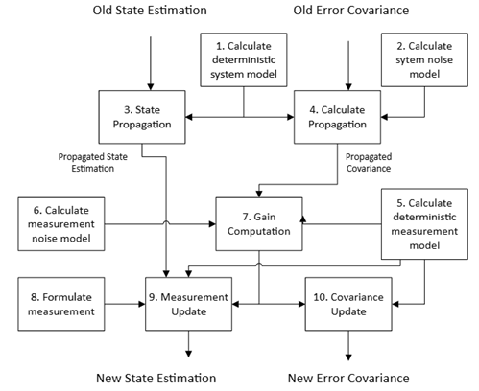
Figure 2. This is a figure. Schemes follow the same formatting.
Figure 2 illustrates the step-by-step flow of the Kalman filter from a previous state estimate to an updated state estimate within the POD. In the proposed approach, this recursive process is divided into two fundamental phases: state propagation and measurement update. Starting from the previous state estimate ${\hat{x}}_{k-1}^{+}$, the deterministic system model is first evaluated. The predicted (a priori) state is computed in Eq. (3).
${\hat{x}}_{k}^{-}=f({\hat{x}}_{k-1}^{+})$ (3)
In this formulation, the function f(⋅) describes the discrete time orbital state transition derived from numerical integration of the satellite motion equations. The propagated state provides a one second prediction of satellite position and velocity between two consecutive precise orbit product epochs. In parallel with state propagation, the error covariance matrix is propagated to reflect increasing uncertainty and evolving correlations as seen in Eq. (4).
$P_{k}^{-}=F_{k}P_{k-1}^{+}F_{k}^{T}+Q_{k}$ (4)
Here $F_{k}$ is the Jacobian matrix of the nonlinear orbital dynamics model with respect to the state vector, evaluated at the predicted state, and $Q_{k}$ is the process noise covariance matrix. When a new precise orbit epoch becomes available (e.g., every 300 second or 900 second), the deterministic measurement model is evaluated as given in Eq. (5).
${\hat{z}}_{k}=h({\hat{x}}_{k}^{-})$ (5)
Where h(-) maps the predicted orbital state to the measurement space defined by the externally provided high-precision satellite position coordinates in the ECEF frame. The reliability of this measurement is characterized by the measurement noise covariance matrix $R_{k}$. The Kalman gain, which determines the relative weighting between the propagated orbital prediction and the incoming precise orbit measurement, is computed as seen in Eq. (6).
$K_{k}=P_{k}^{-}H_{k}^{T}{(H_{k}P_{k}^{-}H_{k}^{T}+R_{k})}^{-1}$ (6)
Where $H_{k}$ is the Jacobian (measurement matrix) of the observation model evaluated at the predicted state. In the POD context, the Kalman gain regulates how strongly the discrete precise orbit coordinates should correct the dynamically propagated one-second orbit solution. If the measurement covariance is small, the filter gives higher weight to the precise orbit product; conversely, larger $R_{k}$ values increase reliance on the dynamic model. The measurement innovation is defined as seen in Eq. (7).
$y_{k}=z_{k}-{\hat{z}}_{k}$ (7)
Where $z_{k}$ represents the precise orbit position at epoch k, and ${\hat{z}}_{k}$ is the predicted measurement derived from the propagated state. Accordingly, the state estimate is updated using the Kalman gain as shown in Eq. (8).
${\hat{x}}_{k}^{+}={\hat{x}}_{k}^{-}-K_{k}y_{k}$ (8)
Through this correction step, not only are position states adjusted, but velocity are also refined indirectly via the existing correlation structure embedded in the covariance matrix. Finally, the updated error covariance matrix is computed as seen in Eq. (9).
$P_{k}^{+}=(I-K_{k}H_{k})P_{k}^{-}$ (9)
which reflects the reduction in uncertainty resulting from the incorporation of the new measurement.

2.3. Machine Learning Based Orbit Reconstruction
In addition to deterministic Lagrange interpolation and Kalman filtering, machine learning algorithms are investigated as data driven alternatives for high-rate satellite orbit reconstruction. Unlike physically based dynamic models, Machine learning approaches aim to learn nonlinear temporal relationships directly from orbit data. Within this context, RF, SVR, KNN and MLP are implemented to approximate the mapping between sparsely sampled precise orbit epochs (e.g., 300 second or 900 second intervals) and intermediate one-second coordinate estimates.
RF is an ensemble regression algorithm that aggregates predictions from multiple decision trees trained on randomly sampled subsets of the data. Through bootstrap sampling and random feature selection, RF reduces variance compared to a single decision tree and improves predictive stability. The final prediction is obtained by averaging the outputs of individual trees, thereby enhancing robustness against noise and overfitting. In the context of orbit reconstruction, RF models the nonlinear relationship between discrete precise orbit coordinates and high rate intermediate positions. Its ensemble structure enables the capture of complex temporal patterns in satellite orbit data and has previously demonstrated effectiveness in GNSS related estimation problems [20].
SVR, the regression formulation of Support Vector Machines, constructs an optimal regression function by minimizing structural risk while maintaining an ε-insensitive error margin. For the linear case, the regression function is expressed as seen Eq. (10)
$y=\sum_{i=1}^{N}{a_{i}}x_{i}+b$ (10)
where $a_{i}$ are weighting coefficients and $b$ is the bias term. However, satellite orbit evolution is inherently nonlinear; therefore, kernel functions are employed to project input data into a higher dimensional feature space. The nonlinear SVR model is written as seen Eq. (11)
$y=\sum_{i=1}^{N}{a_{i}}K(x_{i},x)+b$ (11)
where $K(x_{i},x)$ is the kernel function. The polynomial kernel and Gaussian radial basis function (RBF) are shown in equations (12) and (13), respectively.
$K(x_{i},x)=(x_{i}⋅x)^{d}$ (12)
$K(x_{i},x_{j})=exp⁡(\frac{∥x_{i}-x_{j}∥^{2}}{2σ^{2}})$ (13)
Through appropriate kernel and margin parameter selection, SVR approximates the nonlinear temporal evolution of satellite coordinates under sparse sampling conditions. As demonstrated in previous GNSS parameter estimation studies [20], margin based learning approaches can provide high precision regression.
KNN is a non-parametric, instance-based learning algorithm that predicts the value of a new data point by averaging the values of its k nearest neighbors in the feature space. The selection of k is a crucial hyperparameter, as it dictates the local neighborhood size influencing the prediction, with smaller k values leading to more sensitive and potentially noisy predictions, while larger k values can smooth out noise but risk over smoothing localized patterns. In the context of orbit reconstruction, KNN determines the intermediate satellite position by averaging the positions of its closest neighboring precise orbit epochs, effectively capturing local orbit dynamics without explicit model training [28].
MLP is a feedforward artificial neural network architecture consisting of an input layer, one or more hidden layers, and an output layer. It approximates complex nonlinear functions by composing affine transformations and nonlinear activations across layers, enabling the modeling of intricate temporal patterns in sparse satellite orbit. The computational for neuron j in layer l is described in Eq. (14).
$\hat{y_{j}^{\left(l\right)}}=σ\left(\sum_{i}{w_{ji}^{\left(l\right)}\hat{y_{i}^{\left(l-1\right)}}}+b_{j}^{\left(l\right)}\right)$ (14)
where $w_{ji}^{\left(l\right)}$are weights, $b_{j}^{\left(l\right)}$ is bias, and σ(⋅) is the activation function [29]. During forward propagation, x inputs are transformed layer-by-layer to yield prediction $\hat{y}$. Training minimizes a loss $L\left(\hat{y},y\right)$using backpropagation and gradient descent: $w_{ji}^{\left(l\right)}←w_{ji}^{\left(l\right)}-η\frac{∂L}{∂w_{ji}^{\left(l\right)}}$ where η is the learning rate. Hyperparameters such as the number of hidden layers, nodes per layer, activation functions, and learning rate critically determine the MLP's capacity to capture nonlinear orbital dynamics from discrete precise orbit epochs to 1-s reconstructions [30].

3. Experiment
In this study, precise satellite orbit products provided by several IGS analysis centers were used. The experiments were conducted using SP3 precise orbit products corresponding to DOY 033 of 2020, which was selected as a representative test day, with corresponding observation data used for PPP processing. IGS analysis centers process GNSS observation networks and generate high precision satellite orbit and clock products that are widely used in precise positioning and orbit determination studies. Among the analysis centers listed in Table 1, CODE, operated by the Astronomical Institute of the University of Bern, is one of the primary centers responsible for producing precise multi GNSS orbit and clock solutions using globally distributed tracking stations. GFZ also functions as an official IGS analysis center and produces ultra-rapid, rapid, and final orbit solutions derived from a global GNSS tracking network. In addition, JAXA provides precise orbit and clock products through its multi GNSS orbit determination system, which processes observations from international GNSS monitoring networks. GRG and SHA similarly generate multi GNSS precise orbit solutions within the MGEX, contributing to the production of global precise orbit products. For the experiment, two different temporal resolutions of SP3 precise orbit products were employed. The datasets generated by CODE, GFZ, and JAXA provide satellite orbit coordinates at 5-minute intervals, whereas the products generated by GRG and SHA provide orbit coordinates at 15-minute intervals. These datasets were used as reference orbit information to evaluate the performance of the proposed high rate orbit products.
Table 1. Precise orbit data provider used in this study.
Analysis Center | Institution | Country | SP3 Sampling Interval
CODE | Center for Orbit Determination in Europe, University of Bern | Switzerland | 5 min
GFZ | GeoForschungsZentrum Potsdam | Germany | 5 min
JAXA | Japan Aerospace Exploration | Japan | 5 min
GRG | CNES/CLS Analysis Center | France | 15 min
SHA | Shanghai Astronomical Observatory | China | 15 min

To obtain 1-second satellite orbit estimates, a range of interpolation and prediction algorithms were investigated, including 9th-degree Lagrange interpolation using precise orbit products as reference data, along with machine learning methods (MLP, SVR, KNN, RF) and the EKF. The performance of these algorithms was assessed by reconstructing high rate satellite positions from the lower rate precise orbit products.
For the RF model, the number of trees (n_estimators) was set to 150, providing a balance between prediction accuracy and computational efficiency for high-rate (1 Hz) orbit reconstruction. Increasing the number of trees beyond this value resulted in negligible improvements in 3D RMS while significantly increasing inference time. For SVR, the RBF kernel was selected due to its ability to capture nonlinear orbital dynamics and ensure smooth transitions between prediction points. In the KNN model, the number of neighbors was set to k = 9, corresponding to an effective temporal window of approximately two hours, enabling the capture of local orbital curvature while reducing noise sensitivity. The MLP architecture was defined with a single hidden layer of 50 neurons to balance model complexity and generalization, with max_iter = 2000 to ensure stable convergence. For the EKF, the measurement noise covariance was set to 10^(-6) km², approximately 1m², reflecting the high accuracy of SP3 products, while the process noise was defined as Q_pos=10^(-4) km² and Q_vel=10^(-2) (km/s)² to account for unmodeled perturbations, primarily affecting velocity states. The process noise was further scaled with the integration interval (Q⋅dt), allowing the filter to adapt to varying sampling intervals (300 s and 900 s) without manual tuning. For Lagrange interpolation, a 9th-degree polynomial with 10 observation points was employed, consistent with standard practices in GNSS orbit reconstruction studies.
To evaluate the interpolation and prediction performance, a Leave-One-Out Cross-Validation (LOO-CV) strategy was adopted. In this approach, each epoch was sequentially excluded, and the models were trained on the remaining data to estimate the satellite position at the removed epoch. The predicted coordinates were then compared with the corresponding SP3 precise orbit positions, treated as reference values. The performance was assessed using three metrics. The 3D position error is defined in Eq. (15), and the overall accuracy was quantified using the 3D RMSE (Eq. 16), where N denotes the number of evaluated epochs. In addition, the maximum error was computed to capture the largest deviation, and the 95th percentile error was used to provide a robust measure less sensitive to outliers. These metrics collectively enable a comprehensive evaluation of both average accuracy and extreme deviations in reconstructed satellite orbits.
$e_{3D}=\sqrt{\left(X_{p}-X_{r})^{2}+(Y_{p}-Y_{r})^{2}+(Z_{p}-Z_{r})^{2}\right.}$ (15)
$RMSE_{3D}=\sqrt{\frac{1}{N}\sum_{i=1}^{N}{e_{3D,i}^{2}}}$ (16)
In addition to the LOO-CV evaluation, the predicted 1-second precise orbit products were further assessed through PPP processing using the RTKLIB software. The resulting positioning solutions were compared to evaluate the impact of orbit reconstruction accuracy on PPP performance.

4. Results
This section presents the performance evaluation of the proposed orbit reconstruction methods. The results are organized to first assess the accuracy of reconstructed satellite orbits using statistical error metrics, followed by an evaluation of their impact on PPP positioning performance. Orbit reconstruction performance is analyzed through comparative results obtained from Lagrange interpolation, EKF-based estimation, and machine learning models. Representative results from a selected GPS satellite (G11) are presented, as similar performance trends were observed across the full constellation (G01–G32). To ensure a clear and focused evaluation, only representative results are included in the manuscript, while the complete dataset, including all satellite results and corresponding observation data, is publicly available in the GitHub repository [https://github.com/fkarlitepe/Estimation-Orbit]. Subsequently, the influence of the reconstructed 1-second orbit products on PPP solutions is examined using RTKLIB, providing insight into the practical implications of orbit estimation accuracy.

4.1. 300 second interval dataset performance
The one-day dataset with a 300 second sampling interval was generated by the CODE, GFZ, and JAXA analysis centers. The estimation performance of different algorithms was evaluated based on 3D position RMSE values and is presented in Table 2. As all three analysis centers exhibit highly consistent results across different methods, the graphical representations are presented using the CODE dataset.
Table 2. 3D Position RMSE Comparison of Orbit Estimation Methods for 300 second Interval Datasets
3D Position RMS (Satellite G11) | RF | SVR | KNN | MLP | EKF | Lagrange
CODE | 175908 m | 2959200 m | 353315 m | 5940889 m | 85 m | 62 m
GFZ | 175300 m | 291407 m | 354373 m | 5870083 m | 85 m | 62 m
JAXA | 175908 m | 2958565 m | 353315 m | 5940889 m | 85 m | 62 m

As summarized in Table 2, EKF and Lagrange achieve the lowest RMSE values (85 m and 62 m, respectively), indicating superior estimation accuracy. RF and KNN exhibit moderate error levels, while SVR and MLP produce significantly higher RMSE values, reaching the order of kilometers.
The orbit comparison results (Figure 3) show that EKF and Lagrange closely follow the reference orbit across all coordinate components, whereas RF and KNN exhibit noticeable deviations, and SVR and MLP show substantial discrepancies. Consistently, the model-based 3D position errors (Figure 4) indicate that EKF and Lagrange maintain low and stable error levels over time, while the other methods demonstrate increased variability and larger error magnitudes.
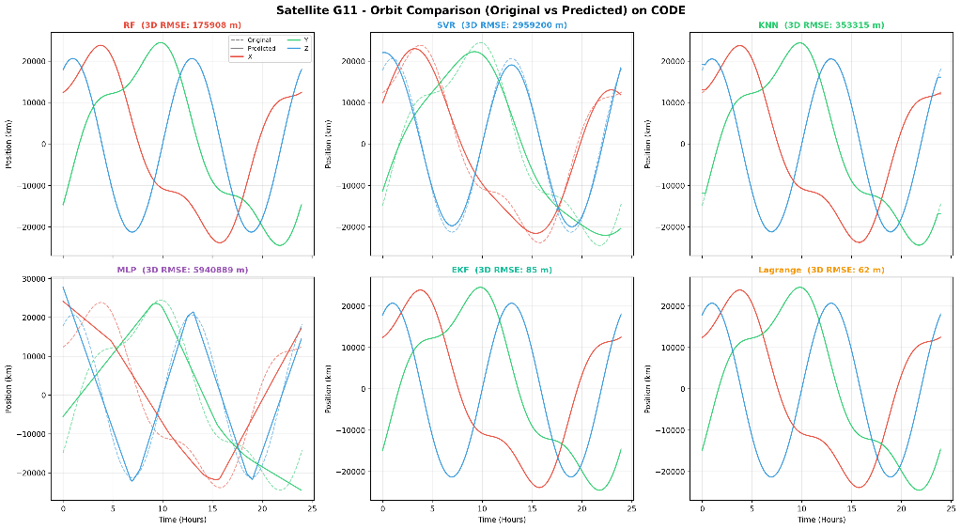
Figure 3. Estimation Performance for the CODE Analysis Center
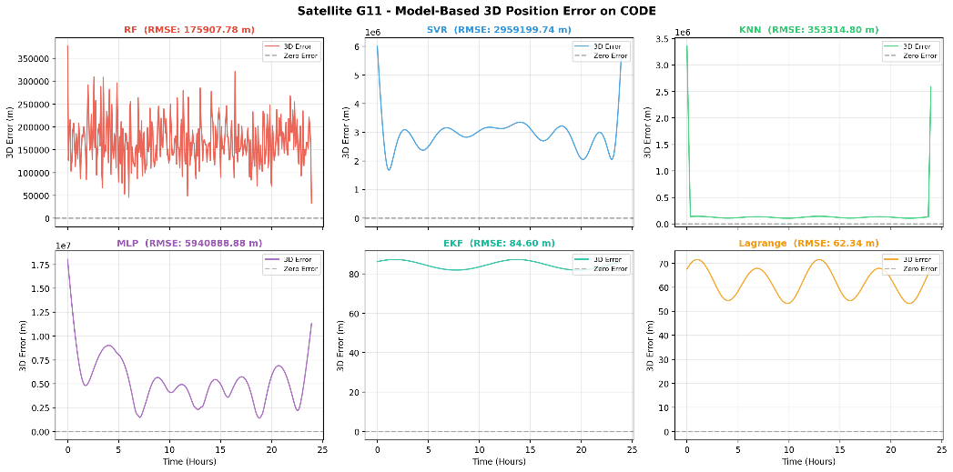
Figure 4. Model-Based 3D Position Error (LOO-CV) for CODE Analysis Center
The LOO-CV RMSE comparison (Figure 5) further confirms these findings. EKF and Lagrange provide the lowest error values, followed by RF and KNN, while SVR and MLP show considerably higher RMSE values.

Figure 5. LOO-CV 3D RMS comparison on CODE
The graphical analyses focus on the G11 satellite from the CODE dataset as a representative case. The LOO-CV RMSE results reveal clear performance differences among the methods. RF, SVR, KNN, and MLP yield RMSE values of 500.3 km, 3338.2 km, 739.7 km, and 6073.8 km, respectively, whereas EKF achieves a significantly lower RMSE of 16.7 km.

4.2. 900 second interval dataset performance
The one-day dataset with a 900 second sampling interval was generated by GRG and SHA. The estimation results for all satellites were evaluated using 3D position RMSE and are summarized in Table 3. Both analysis centers produce nearly identical results across all estimation algorithms. Compared to the 300 second dataset, RMSE values increase for all methods due to the lower temporal resolution.
Table 3. 3D Position RMSE Comparison of Orbit Estimation Methods for 900 second Interval Datasets
3D Position RMS (Satellite G11) | RF | SVR | KNN | MLP | EKF | Lagrange
GRG | 540763.11 m | 4155725.76 m | 2009342.42 m | 6577248,66 m | 255.12 m | 187.17 m
SHA | 540763 m | 4156055 m | 2009342 m | 6577249 m | 255 m | 187 m

According to Table 3, EKF and Lagrange again achieve the lowest RMSE values (approximately 255 m and 187 m, respectively), although with increased errors compared to the higher-rate dataset. RF and KNN show moderate degradation, while SVR and MLP produce substantially higher errors, reaching several thousand kilometers.
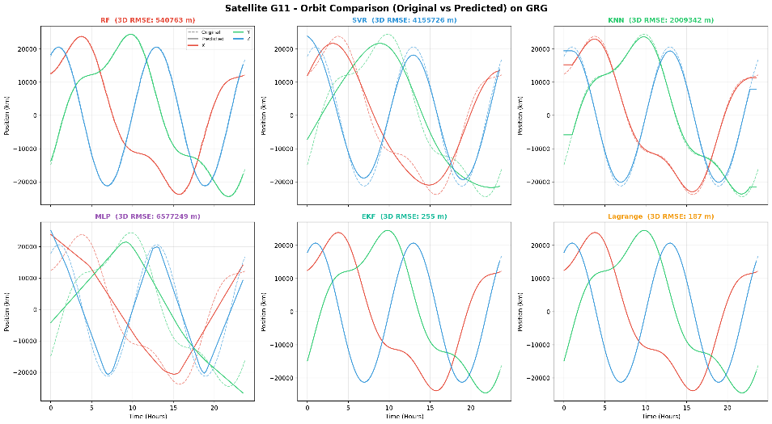
Figure 6. Orbit Estimation Performance for the GRG Analysis Center
The graphical analyses are presented using the GRG dataset. The orbit comparison results (Figure 6) show that EKF and Lagrange maintain close agreement with the reference orbit, with slight degradation compared to the 300 second case, while the remaining methods exhibit more pronounced deviations.
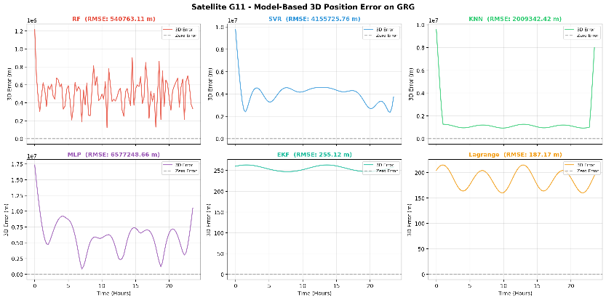
Figure 7. Orbit Estimation Performance for the GRG Analysis Center
The model-based 3D position errors (Figure 7) indicate increased error magnitudes across all methods. EKF and Lagrange preserve relatively stable behavior, whereas RF shows increased variability and the other methods produce significantly larger and less stable errors.
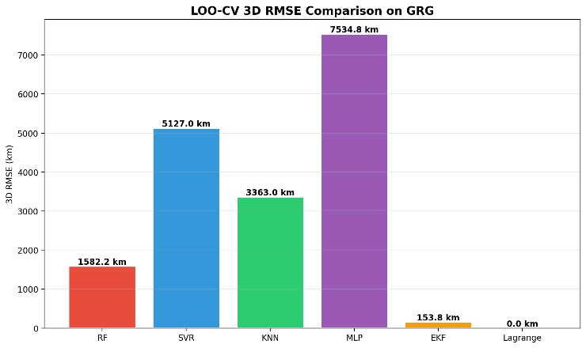
Figure 8. Orbit Estimation Performance for the GRG Analysis Center
The LOO-CV RMSE comparison (Figure 8) confirms the performance degradation at lower temporal resolution. Nevertheless, EKF and Lagrange remain the best-performing methods, followed by RF and KNN, while SVR and MLP exhibit the highest error levels.The one-day dataset with a 900 second sampling interval was generated by GRG and SHA. The estimation results for all satellites were evaluated using 3D position RMSE and are summarized in Table 3. It is observed that both analysis centers produce nearly identical results across all estimation algorithms. Compared to the 300 second dataset, a general increase in RMSE values is observed for all methods.

4.3. Comparision of analysis centers
Comparison across analysis centers is presented in Figure 9 based on EKF results, as EKF provides a robust and representative estimation framework while closely following the reference performance achieved by Lagrange interpolation. It is observed that CODE, GFZ, and JAXA yield nearly identical RMSE values, indicating consistent performance for the 300 second datasets. In contrast, GRG and SHA exhibit significantly higher RMSE values corresponding to the 900 second datasets.
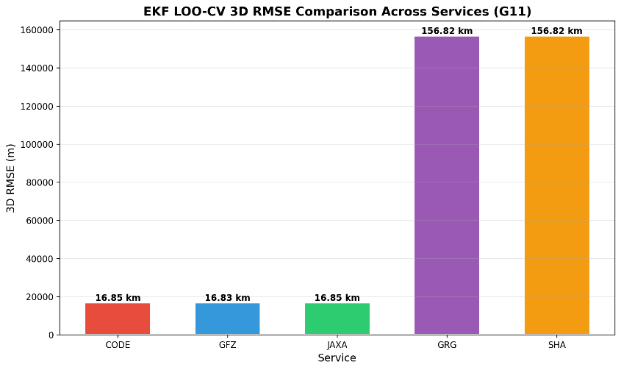
Figure 9. Orbit Estimation Performance for the GRG Analysis Center

4.4. RTKLIB PPP Process Solution
The 1-second SP3 orbit products were evaluated within the RTKLIB PPP processing to assess their impact on positioning performance. All solutions were generated using the same observation file (ankr0330.20o), broadcast ephemeris (ankr0330.20n), and precise clock product (igs20910.clk) to ensure consistency. For comparison, PPP solutions were also computed using final SP3 products from different analysis centers, including CODE, GFZ, JAXA, GRG, and SHA. The resulting positions were compared with those obtained using the 1-second orbit products. Positioning performance was analyzed in the East–North–Up (ENU) frame, as it provides a direct interpretation of local positioning errors. This representation allows a clear separation of horizontal and vertical components, making it more suitable for comparative PPP analysis than ECEF coordinates.
Table 4. ENU-based positioning errors and standard deviations for different analysis center products
Analyze Center | East (m) | North (m) | Up (m) | Sd E | Sd N | Sd U
CODE | -102.056 | 350.495 | -23.5806 | 1.5201 | 4.2077 | 7.0025
GFZ | 2.0739 | 7.4277 | 1.2184 | 1.4735 | 4.8134 | 7.489
GRG | 96.9106 | -126.833 | -737.828 | 1.5289 | 8.3883 | 11.4591
JAXA | -102.046 | 350.435 | -23.6807 | 1.5201 | 4.2077 | 7.0025
SHA | 96.8681 | -126.839 | -737.639 | 1.5289 | 8.3883 | 11.4591

The ENU results (Table 4) indicate that the solutions obtained from CODE and JAXA exhibit nearly identical performance, both in coordinate components and standard deviations, highlighting their consistency. GFZ results remain close to this level, with only minor deviations. In contrast, GRG and SHA show significantly larger errors, particularly in the Up component, where deviations exceed 700 m. This indicates a substantial degradation in vertical positioning performance for these products. For consistency, ENU reference coordinates were derived from the PPP solution computed using the corresponding final SP3 product of each analysis center. Accordingly, each solution was evaluated against its own reference, eliminating potential biases due to reference frame differences. Overall, the ENU-based evaluation clearly reveals the impact of orbit product quality on PPP performance and provides a reliable basis for comparing different solutions.

5. Conclusions
The results demonstrate that EKF and Lagrange interpolation outperform machine learning approaches in reconstructing high-rate satellite orbits, providing stable and low-error solutions across different datasets. While RF and KNN achieve moderate performance, SVR and MLP exhibit significantly larger errors, indicating their limited capability in capturing the temporal dynamics of satellite motion under sparse sampling conditions. The analysis also shows that the sampling interval of precise orbit products plays a critical role, where 300 s datasets consistently yield higher accuracy compared to 900 s datasets, highlighting the sensitivity of reconstruction methods to input data resolution.
From a positioning perspective, PPP results confirm that orbit quality directly propagates into positioning accuracy. The ENU-based evaluation enables a clear interpretation of local positioning errors and reveals differences between analysis centers, particularly in the vertical component. High-quality products provide consistent and reliable solutions, whereas lower-quality products introduce significant deviations. EKF-based orbit reconstruction emerges as a strong alternative to classical interpolation by enabling continuous orbit propagation while maintaining comparable accuracy and offering greater flexibility for sequential estimation. However, machine learning models remain insufficient for high-precision PPP applications in their current configuration. Future work should focus on hybrid modeling strategies that combine dynamic filtering with machine learning approaches, as well as the integration of clock estimation and multi-GNSS analysis to further enhance positioning performance.

6. Patents
Author Contributions: Furkan Karlitepe (ORCID: 0000-0003-4972-1565): Conceptualization, methodology, software, data analysis, writing – original draft, writing – review & editing. Emirhan Uysal: Data processing, validation, visualization, writing – review & editing.
Funding: Please add: “This research received no external funding”
Data Availability Statement: The datasets and code used in this study are publicly available at: https://github.com/fkarlitepe/Estimation-Orbit. Additional data supporting the findings of this study are available from the corresponding author upon reasonable request.
Acknowledgments: The authors would like to thank Tokat Gaziosmanpaşa University for providing the necessary computational resources and support for this study. The authors also acknowledge the International GNSS Service (IGS) for providing high-quality precise orbit and clock products used in this research.
Conflicts of Interest: “The authors declare no conflicts of interest.”

Abbreviations
The following abbreviations are used in this manuscript:
GNSS | Global Navigation Satellite Service
PPP | Precise Point Positioning
IGS | International GNSS Service
RF | Random Forest
SVR | Support Vector Machine
KNN | K-Nearest Neighbor
MLP | Multi Layer Perceptron
EKF | Extended Kalman Filter

References
- Carlin, L., Hauschild, A., & Montenbruck, O. (2021). Precise point positioning with GPS and Galileo broadcast ephemerides. GPS Solutions, 25(2). https://doi.org/10.1007/s10291-021-01111-4
- Öğütcü, S. (2019). Performance assessment of IGS Combined/JPL individual rapid and ultra-rapid products: consideration of precise point positioning technique. International Journal of Engineering and Geosciences, 5(1), 1. https://doi.org/10.26833/ijeg.577385
- Chi, C., Zhang, X., Liu, J., Sun, Y., Zhang, Z., & Zhan, X. (2023). GICI-LIB: A GNSS/INS/Camera Integrated Navigation Library. IEEE Robotics and Automation Letters, 8(12), 7970. https://doi.org/10.1109/lra.2023.3324825
- Alkan, R. M., & Kalkan, Y. (2011). Hassas Nokta Konumlama Tekniğinin Hidrografik Ölçmelerde Kullanılabilirliği. Jeodezi ve Jeoinformasyon Dergisi, 104.2, 100-106. https://izlik.org/JA77GC34CM
- Bahadur, B. (2023). Küresel BeiDou Sistemi (BDS-3) için hassas nokta konumlama performansının değerlendirilmesi. Jeodezi ve Jeoinformasyon Dergisi, 10(1), 30-44. https://doi.org/10.9733/JGG.2023R0003
- Naciri, N., Yi, D., Bisnath, S., Blas, F. J. de, & Capua, R. (2023). Assessment of Galileo High Accuracy Service (HAS) test signals and preliminary positioning performance. GPS Solutions, 27(2). https://doi.org/10.1007/s10291-023-01410-y
- El‐Tokhey, M. (2019). Assessment of Single and Precise Point Positioning Over Long Observational Periods. International Journal of Engineering Research And, 5. https://doi.org/10.17577/ijertv8is050112
- Oliveira, P. S. de. (2017). Definition and implementation of a new service for precise GNSS positioning. HAL (Le Centre Pour La Communication Scientifique Directe). https://tel.archives-ouvertes.fr/tel-01695792
- Aziz, K. M. A., & Elsonbaty, L. (2021). EFFECT OF USING DIFFERENT SATELLITE EPHEMERIDES ON GPS PPP AND POST PROCESSING TECHNIQUES. Geodesy and Cartography, 47(3), 104. https://doi.org/10.3846/gac.2021.13762
- Martín, Á., Julián, A. B. A., Dimas-Pages, A., & Cos-Gayón, F. (2015). Validation of performance of real-time kinematic PPP. A possible tool for deformation monitoring. Measurement, 69, 95. https://doi.org/10.1016/j.measurement.2015.03.026
- Yao, W., Huang, H., Ma, X., Zhang, Q., Yao, Y., Lin, X., Qingzhi, Z., & Huang, Y. (2024). Multi-Global Navigation Satellite System (GNSS) real-time tropospheric delay retrieval based on state-space representation (SSR) products from different analysis centers. Annales Geophysicae, 42(2), 455. https://doi.org/10.5194/angeo-42-455-2024
- Öcalan, T., & Soycan, M. (2011). GNSS Verisinin Gerçek Zamanlı İletimi İçin Uluslararası Standartlar ve Gelişmeler. Jeodezi ve Jeoinformasyon Dergisi, 104.2, 123-133. https://izlik.org/JA26NY28UC
- Erdogan, B., Karlitepe, F., Ocalan, T., & Tunalioglu, N. (2018). Performance analysis of real time PPP for transit of Mercury. Measurement, 129, 358–367. https://doi.org/10.1016/j.measurement.2018.07.050
- Qafisheh, M. W. A., Martín, Á., Capilla, R. M., & Julián, A. B. A. (2022). SVR and ARIMA models as machine learning solutions for solving the latency problem in real-time clock corrections. GPS Solutions, 26(3). https://doi.org/10.1007/s10291-022-01270-y
- Wang, J., Li, Y., Zhu, H. & Ma, T. (2018). Interpolation Method Research and Precision Analysis of GPS Satellite Position. Journal of Systems Science and Information, 6(3), 277-288. https://doi.org/10.21078/JSSI-2018-277-12
- Hankansurijat, C., & Andrei, C.-O. (2018). Atmospheric Water Estimation Using GNSS Precise Point Positioning Method. Engineering Journal, 22(6), 37. https://doi.org/10.4186/ej.2018.22.6.37
- Hutton, J. J., Gopaul, N., Zhang, X., Wang, J., Menon, V., Rieck, D., Kipka, A., & Pastor, F. (2016). CENTIMETER-LEVEL, ROBUST GNSS-AIDED INERTIAL POST-PROCESSING FOR MOBILE MAPPING WITHOUT LOCAL REFERENCE STATIONS. The international Archives of the Photogrammetry, Remote Sensing and Spatial Information Sciences/International Archives of the Photogrammetry, Remote Sensing and Spatial Information Sciences, 819. https://doi.org/10.5194/isprsarchives-xli-b3-819-2016
- Wang, J., Li, H., Wu, S., Wang, Y., & Nie, G. (2026). DE-optimized EKF for bridge deformation monitoring using GNSS and accelerometers. Measurement Science and Technology, 37(12), 125002. https://doi.org/10.1088/1361-6501/ae5402
- Liu, X., Han, H., Wang, J., Hancock, C., Smith, A., & Yu, H. (2026). A GNSS/accelerometer integrated deformation monitoring model using fractional Kalman filtering. Measurement Science and Technology, 37(12), 126302. https://doi.org/10.1088/1361-6501/ae507f
- Karlitepe, F., Erdogan, B. Machine learning algorithms for FCB (fractional cycle bias) estimation in PPP ambiguity resolution. Arab J Geosci 18, 139 (2025). https://doi.org/10.1007/s12517-025-12276-4
- Lou, Y., Dai, X., Gong, X., Li, C., Qing, Y., Liu, Y., Peng, Y., & Gu, S. (2022). A review of real-time multi GNSS precise orbit determination based on the filter method [Review of A review of real-time multi GNSS precise orbit determination based on the filter method]. Satellite Navigation, 3(1). Springer Nature. https://doi.org/10.1186/s43020-022-00075-1
- Xie, S., Li, J., & Cai, J. (2025). Improving High-Precision BDS-3 Satellite Orbit Prediction Using a Self-Attention-Enhanced Deep Learning Model. Sensors, 25(9), 2844. https://doi.org/10.3390/s25092844
- Mohanty, A., & Gao, G. (2024). A survey of machine learning techniques for improving Global Navigation Satellite Systems. EURASIP Journal on Advances in Signal Processing, 2024(1). https://doi.org/10.1186/s13634-024-01167-7
- Gao, W., Li, Z., Chen, Q., Jiang, W., & Feng, Y. (2022). Modelling and prediction of GNSS time series using GBDT, LSTM and SVM machine learning approaches. Journal of Geodesy, 96(10). https://doi.org/10.1007/s00190-022-01662-5
- Gou, J., Rösch, C., Shehaj, E., Chen, K., Kiani Shahvandi, M., Soja, B., & Rothacher, M. (2023). Modeling the Differences between Ultra-Rapid and Final Orbit Products of GPS Satellites Using Machine-Learning Approaches. Remote Sensing, 15(23), 5585. https://doi.org/10.3390/rs15235585
- Groves, P. D. (2008). Principles of GNSS. Inertial, and Multisensor Integrated Navigation Systems, 521.
- Kavitha, S., Mula, P., Kamat, M., Nirmala, S., & Manathara, J. G. (2022). Extended Kalman filter-based precise orbit estimation of LEO satellites using GPS range measurements. IFAC PapersOnLine, 55(1), 235–240. https://doi.org/10.1016/j.ifacol.2022.04.039
- Elshazli, M. T., Hussein, D., Bhat, G., Abdel-Rahim, A., & Ibrahim, A. (2024). Advancing infrastructure resilience: machine learning-based prediction of bridges’ rating factors under autonomous truck platoons. Journal of Infrastructure Preservation and Resilience, 5(1). https://doi.org/10.1186/s43065-024-00096-x
- Hu, T., Xu, X., Luo, J., Hou, J., & Liu, H. (2025). Global ionospheric sporadic E intensity prediction from GNSS RO using a novel stacking machine learning method incorporated with physical observations. Atmospheric Chemistry and Physics, 25(18), 11517. https://doi.org/10.5194/acp-25-11517-2025
- Albuquerque, P. K. de, Kuroswiski, A. R., Wu, A. S., Santos, W. G. dos, & Costa, P. (2025). Orbit Determination through Cosmic Microwave Background Radiation. arXiv (Cornell University). https://doi.org/10.48550/arxiv.2504.02196

